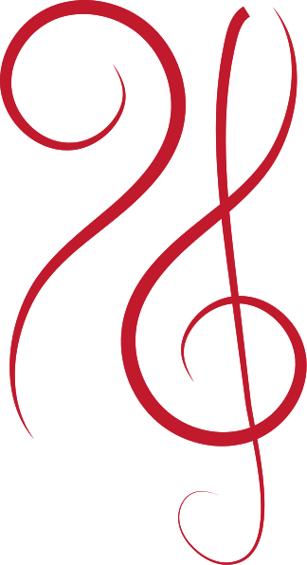
Traditional
C
arranged by CaptaNova

DONA NOBIS PACEM

Traditional
arranged by CaptaNova

DONA NOBIS PACEM

Duration: 2‘30‘‘ | Difficulty: ♪ ♪ ♪

INSTRUMENTATION
Flute
Oboe
Bb Clarinet
Bassoon

Glockenspiel
Triangle (optional)
Violin 1
Violin 2
Viola
Violoncello
Double Bass

PROGRAM NOTES
Dona nobis pacem is the Latin text of a song that is often sung as a canon. The words „Dona nobis pacem“ are the last words of the Agnus Dei of the Catholic Mass and mean „Give us peace“ (prayer for peace). The origin of the melody is unknown, although it is occasionally attributed to Giovanni Pierluigi da Palestrina or Wolfgang Amadeus Mozart.

NOTES TO THE CONDUCTOR

In part A, the Glockenspiel can be supported by a flute or a solo violin due to the long notes in the second and third phrase of the canon. If no Glockenspiel is available, this part can also be played by a flute.

The actual canon begins with part B (bar 33) and is complete with the entry of the third voice in bar 49. The singers are supported ostinatively by the complete string section.

This part can be repeated as often as you like before the piece is finally continued in the second bracket. It is also possible to perform this part alone (choir with ostinato). If the ostinato is repeated several times, the triangle should not be played in every repetition.

For a particularly soft end to the song, it is recommended that the concluding part of the first voice ( starting at bar 62) be sung by only a few singers or a small group of children.

LYRICS

Dona nobis pacem.

cb | © 2015 by CaptaNova. Dona nobis pacem  This work is licensed under a Creative Commons Attribution 4.0 International license.  To view a copy of this license visit http://creativecommons.org/licenses/by/4.0/

